**Prayers for the Growing Justice Palestinian olive harvest focus, Fall 2024**  
  
*Compiled by Rev Ursula Wiig, Living Skies Regional Council (The United Church of Canada in Saskatchewan)*  
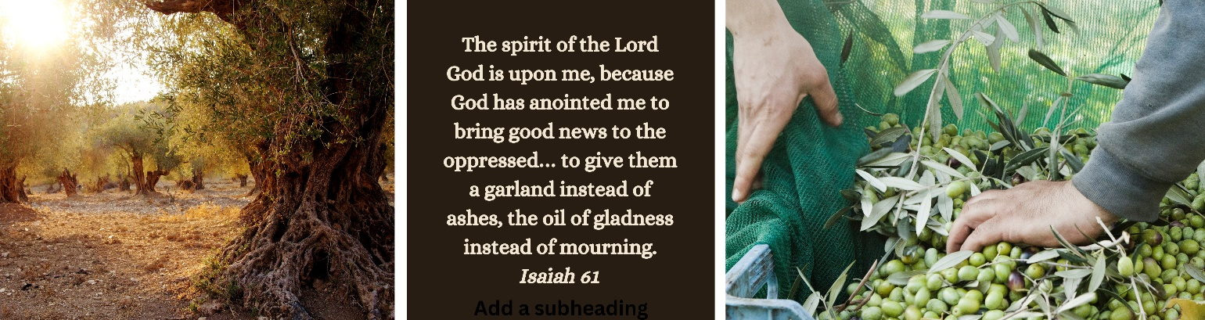  
 **Embolden Justice, the United Church of Canada**  
Steadfast God,  
As we witness to the horrors and heartbreak in Israel and Palestine, we seek your comfort and strength, your shelter and hope, your peace and your blessings.

Bless all those who continually attempt to live your teachings of compassion and reconciliation  
through humanitarian aid and advocacy for those most affected by the atrocities of war.  
These actions are green leaves on a weakening tree, clear signs of hope, even as fear, death, and grief overwhelm.

Bless all those who mourn, whose heartbreak and sorrow are too deep for words. In their despair may your unshakeable roots protect and hold them in love. And provide us all with the strength to yearn “more than those who watch for morning” for a time when peace prevails globally and in the Middle East.

Bless all who prayerfully seek a peace that leads toward abundant life for all people. Help those of us more removed from the direct conflict to care for and support those of us who are most affected in the Middle East and in our local communities. May we honestly wrestle with our complex emotions, biases, and limited information so that we can work with others toward peace-building that is guided by justice, compassion, and mercy. Together, may we anticipate a time when Israel and Palestine will be a symbol of justice, peace, and liberation for all.

Like an olive tree planted by water,  
sending out its roots by the stream,  
may our commitment toward a just peace in Israel and Palestine never falter,  
     may our hope not be uprooted,  
     may our actions bear good fruit,  
     may our love be steadfast.

[Until freedom and justice for all comes,  
may it be so.  
Amen.](https://united-church.ca/prayers/prayer-peace-middle-east) (<https://united-church.ca/prayers/prayer-peace-middle-east>)

# **Christians 4 a Free Palestine, British Columbia**

Where a desire for vengeance grows   
may those who hunger and thirst   
for healing justice be satisfied.

When violence wounds,  
kills and traumatizes,  
may peace mend, renew and restore.

Where mercy has run dry  
and evil is unleashed,  
may justice flow like a mighty river.

Where governments and militias war  
may your kin-dom come.

May your will be done   
on earth as it is in heaven.   
Amen

**Prayer for Peace in the Middle East**   
God of mercy and compassion, of grace and reconciliation, pour your power upon all your children in the Middle East: Jews, Muslims and Christians, Palestinians and Israelis. Let hatred be turned into love, fear to trust, despair to hope, oppression to freedom, occupation to liberation, that violent encounters may be replaced by loving embraces, and peace and justice could be experienced by all.   
- *Reverend Said Ailabouni*

**Litany of Peace**   
One God, so many people are in pain.   
All Teach us the way to peace.   
One When people around us don't agree and think differently,   
All Teach us to listen and try to understand.   
One When we see people getting hurt,   
All Teach us to speak up.   
One When we see people treated poorly because of their skin color, or language,   
 or religious belief,   
All Teach us to be an example of love and acceptance.   
One When we see war and conflict,   
All Teach us how to make a difference and seek peace.   
One When we see pain,   
All Teach us to bring healing,   
One When we feel confused and afraid,   
All Remind us to talk to our friends, our family and to you.   
One In our lives, our neighborhoods and the world,   
All Teach us to pray and teach us the way of peace.   
 *(Evangelical Lutheran Church in America - Posted on Queen’s House of Retreats website)***Prayers for Peace,** *University of Chicago, Rockefeller Memorial Chapel*

Sustain together in undiminished hope, O God of hope,   
those who continue to labor with undiminished determination   
to build peace in the land from which, of old,   
out of brokenness, violence and destruction,   
nevertheless hope emerged for so many of faith. . . .   
  
Bless all the spiritual seed of Abraham together   
with the light of your Presence.   
For in the light of your Presence   
we have found a way of justice and mercy   
and a vision of Peace.   
We praise you O God, Giver of Peace,   
who commands us to Peace. Amen   
*Rabbi Herbert Bronstein Northshore Congregation Israel, Glencoe, IL*

**Prayer for Peace: For the People of the Middle East**   
God of All,  
Protector and Redeemer,  
Watch over the people of the Middle East  
As their [our] nations face struggle and strife,  
In these lands and on these borders.  
Grant safety to their [our] citizens and residents,  
Visitors and guests,  
During moments of unrest.  
Grant wisdom and courage to national leaders  
Throughout the region.  
Grant insight to their advisors  
And understanding to their friends.  
Lead them on a path toward justice.  
Direct them on the road to freedom.  
Guide them on the way to prosperity.  
Make them all shining lights of peace.

Source and Shelter,  
Grant safety and security to all nations,  
So that harmony and blessings resound  
From the four corners of the earth.

Blessed are You, God of All,  
Forging nations and peoples  
In the crucible of change  
Throughout history.  
May this time of challenge for the nations of the Middle East  
Become a blessing for all inhabitants and for the world.

***Alden Solovy, Reform Judaism***

### Prayer from the Palestine-Israel Network of Mennonite Church Canada ****(posted on https://www.mennonitechurch.ca/)****

God of love and justice, our hearts are perplexed, paralyzed and broken at the recent carnage in Palestine and Israel. We lament the loss of life and the suffering of so many innocent people on both sides. We are shocked at the inhumanity of soldiers and militants.

Our prayers for peace seem to go unanswered. We wish you would intervene. We cling to your promise of a different world, but we see so few signs of its fulfillment. We do not understand.

Still, we continue to believe that you desire life and peace for all people. 

Holy Spirit, strengthen our resolve to advocate for peace, justice, equality, and compassion for all.   Don’t let us turn away.

Comfort all who are overwhelmed with loss—loss of life, loss of homes, loss of safety and security.

God of the vulnerable and the oppressed, neutralize the power of those who thirst for domination and control. Renew the energy and creativity of those committed to nonviolent resistance and change. 

We pray for the Christian communities in the land where Jesus walked and where the church was born. May their witness to your love remain bright among their Muslim and Jewish neighbours. May they recognize your hand in their lives, even amidst the suffering. 

God of all nations, guide our own government to respond in ways that support the legitimate rights of all, especially those who are most vulnerable, those who continue to suffer after decades of occupation, dispossession, and denial of basic human rights and those who fear for their safety.

May your kingdom come, your will be done, on earth as it is in heaven. Yours is the kingdom, the power, the glory, now and forever.  **Amen**